

**BANGLADESH UNIVERSITY OF PROFESSIONALS**

**FACULTY OF SCIENCE AND TECHNOLOGY**

**DEPARTMENT OF COMPUTER SCIENCE & ENGINEERING (CSE)**



**Assignment**

Course Title: Environment, Sustainability and Law

Course Code: GEESL-3211

Group: B4

**Assignment Title:** Assessing Electronic Waste Generation and Management in Dhaka: Challenges and Opportunities

Submitted by:

01. Name: Mohaiminul Islam Raju

ID: 2252421020

02. Name: Shamoyeta Mourin Mouly

ID: 2252421036

03. Name: Latifa Nishat Nishi

ID: 2252421062

04. Name: Jayed Bin Alamgir

ID: 2252421066

05. Name: Tahsina Tabassum Roza

ID: 2252421084

06. Name: Raiyan Bin Sarwar

ID: 2252421096

Submitted to:

Prof. Abdul Kadir Ibne Kamal

Department of Computer Science & Engineering

Faculty of Science & Technology

Bangladesh University of Professionals

#### Abstract

This project explores the current state of e-waste management in Dhaka through surveys and stakeholder insights, revealing critical inefficiencies across the system. Rapid urbanization and high electronic device usage have resulted in substantial e-waste generation, most of which is funneled through informal, unsafe, and environmentally harmful disposal routes. Households lack access to formal collection systems and remain largely unaware of the health and ecological risks of improper e-waste handling. Informal scrap dealers, although central to collection, work in hazardous conditions with minimal training and no regulation. The study emphasizes the urgent need for a shift towards a circular economy model where reuse, refurbishment, and recycling are prioritized to close the loop on electronic consumption. By integrating informal actors into a formalized chain, improving infrastructure, and enforcing extended producer responsibility (EPR), Dhaka can transition to a safer, more inclusive, and sustainable e-waste ecosystem that protects both people and the planet.

Table of Contents

Abstract 4

CHAPTER 1: Introduction 5

1.1 Background Study 5

1.2 Problem Statement 5

1.3 Research Questions 6

1.4 Objectives 6

1.5 Significance of the Study 6

CHAPTER 2: LITERATURE REVIEW 7

2.1 Global Best Practices in E-Waste Management 7

2.2 Existing Studies in Bangladesh and South Asia 8

2.3 Theoretical Frameworks: Circular Economy and Waste Hierarchy 9

2.4 Review of National Policies in Bangladesh 10

2.5 Role of Stakeholders in E-Waste Management 11

CHAPTER 3: Research Gap 12

CHAPTER 4: Methodology 13

4.1 Study Design 13

4.2 Study Area: Rationale for Dhaka North & South 13

4.3 Questionnaire Development: Section-Based Instrument Design 14

4.3.1 Household E-Waste Survey Questionnaire 14

4.3.2 Scrap Dealers E-Waste Survey Questionnaire 15

4.4 Sampling and Data Collection 15

4.4.1 Sampling Approach 15

4.4.2 Data Collection Process 16

4.4.3 Data Management and Quality Control 16

4.5 Data Analysis Plan 16

4.5.1 Statistical Analysis 16

4.5.2 Comparative analysis 16

4.6 Ethical Considerations 17

4.7 Limitations 18

CHAPTER 5: Conclusion 19

CHAPTER 6: Recommendations 20

References 21

Appendices 23

1. Survey Questionnaire Tools 23

2. Studay Area Location 28

3. Study Area Details 29

# Introduction

## Background Study

E-waste is considered to be used, broken, or damaged electrical or electronic devices that are discarded by the original users (Hsu, Stern and Wang, 2024). This includes a wide range of household appliances, such as refrigerators, air conditioners, electric fans, and washing machines, as well as information technology equipment like mobile phones and computers. Additionally, it encompasses consumer electronics, including televisions, radios, solar panels, and batteries that have been previously used. These items may be completely damaged or discarded as garbage because they appear to be old.

With the advancement of modern information and communication technology, people have been using smart devices for their convenience to make life easier and save time. All electronic devices have a lifespan, and inevitably, these devices will turn into waste. Bangladesh is a developing country. In the capital city, Dhaka, a large number of middle-class people reside, and most of them are young. In fact, the young generation constitutes the largest segment of the country’s population. This young generation exhibits a distinct trend towards using modern technological smart devices. This trend is increasing the rate of electronic waste.

Furthermore, the World Trade Organization has decided to eliminate import tariffs on 201 products related to information technology (Taipei Times, 2015). As a result, with the growth of economic activities involving electrical and electronic appliances, gadgets are being used more frequently and efficiently, and these are available at affordable prices. But when the efficiency of these components ends, e-waste is generated.

## Problem Statement

The concentrations of lead, copper, nickel, chromium, and manganese in indoor dust and air samples from e-waste recycling shops are measured in the research by Islam et al. (2021). This study found significantly higher levels of these heavy metals at e-waste collection sites compared to non-recycling areas. The research highlights the growing environmental and health concerns associated with informal e-waste recycling practices in low- and middle-income countries like Bangladesh.

Exposing individuals to these hazardous elements leads to serious diseases, body burden, and health impacts for e-waste workers, including vulnerable groups such as women and children. The mismanagement of the recycling process results in significant health risks like inhalation, ingestion, and dermal contact. In northeastern Bangladesh, 36.3% of women near recycling sites experienced infant mortality, while 15% of child laborers die and 83% suffer long-term health issues due to e-waste exposure (Hossain et al., 2021). The improper and unsustainable recycling methods also contribute to serious environmental pollution. The concentration of lead and mercury in air, water, and soil is higher near dumping and recycling areas than in other sites in Bangladesh (Islam et al., 2021).

Dhaka, a densely populated city, faces an increase in the e-waste stream. However, due to a lack of sustained infrastructure, systematic collection, recycling, and disposal of e-waste remain underdeveloped. Current e-waste management practices in Bangladesh are hindered by inadequate legislation, poor awareness, and informal recycling conditions (Alam and Bahauddin, 2015).

## Research Questions

This study looks into the answer to the following questions. These questions may help us to find a feasible solution to the problems stated already:

* How much e-waste is currently generated in Dhaka annually?
* What are the current practices and ways of collecting, sorting, recycling, and disposal of e-waste in Dhaka that include both informal and formal pathways?
* Who are involved in the management of e-waste, whether directly or indirectly, their roles and activities?
* What are the main responsibilities, challenges, and opportunities of this management and recycling of e-waste?

## Objectives

The primary objectives of this study are to:

* To quantify and categorize the types and volumes of electronic waste generated by households in Dhaka and analyze their disposal practices
* To investigate the operational practices, challenges, and health risks faced by informal scrap dealers involved in e-waste handling and recycling

## Significance of the Study

This vital study holds some significant importance. This can help in filling the knowledge gap on the process of recycling and the management of e-waste in a developing country like Bangladesh. So, this study can help policymakers and planners by providing crucial baseline data that can help formulate evidence-based strategies.

As this study addresses the risks and challenges of the current practices of e-waste recycling, it can provide an improved and sustainable framework that may reduce the hazards. The identification of environmental and health impacts will address the urgency of the problem and urge for more protective measures. Finally, these types of research may guide the government agencies, NGOs, and civil society organizations in amplifying efficient policies, sustainable infrastructure, and awareness campaigns, ultimately contributing to environmental and public health protection in Dhaka. For example, one study demonstrates that sustainable e-waste management systems in Bangladesh can enhance the current 35% recycling rate and provide energy from waste, addressing environmental hazards and improving public awareness (Ananno et al., 2018)

# LITERATURE REVIEW

## Global Best Practices in E-Waste Management

E-waste is among the fastest-growing waste streams globally as a result of technological change, growing digitalization, and shortening product lifespans. Effective e-waste management in developed economies is most commonly founded upon the pillars of effective regulatory policy, producer responsibility, consumer participation, and state-of-the-art recycling facilities. Such international experiences provide valuable insights to inform effective e-waste policy and practice in Dhaka (Balde et al., 2017).

**European Union – The WEEE Directive:** The WEEE Directive of the EU is a groundbreaking law enacting Extended Producer Responsibility (EPR) by making producers financially and operationally responsible for the collection, treatment, and environmentally friendly disposal of electronic products. The directive encourages the creation of national collection systems, stimulates ecodesign for recyclability enhancement, and offers well-defined data monitoring frameworks. EPR in Europe has raised the degree of recycling and assisted in internalizing the environmental cost of electronic products (European Commission, 2020).

**Japan – Home Appliance Recycling Law:** Japan's Home Appliance Recycling Law (HARL) makes manufacturers responsible for recycling a specified set of electronic products such as TVs, refrigerators, washing machines, and air conditioners. The consumer pays a recycling fee and brings the device to collection points, and manufacturers recycle using contracted-out collectors who have licenses. It is a closed system with high material recovery and process safety (Hotta et al., 2009).

**South Korea – Formal-Informal Sector Integration and Smart Collection:** South Korea has a centralized e-waste system financed by EPR, under which producers are required to report the quantity of electronics entering the market and recycle a similar proportion of e-waste. Notably, the Korean model incorporates informal actors by training, registering, and hiring them in formal facilities. The government promotes the participation of the public through cash-back incentives, designated collection points, and mobile applications for monitoring the disposal of e-waste (Park et al., 2022).

**Switzerland and Sweden – Public Engagement and Infrastructure Excellence:** Switzerland and Sweden are leaders in public participation and effective recycling. In Switzerland, collection centers are located in every municipality, and e-waste cannot be thrown in landfills. Sorting technologies and recovery systems improve resource efficiency. Sweden supports its infrastructure with education campaigns and maintains strong public trust in municipal systems. These countries are great examples of high public engagement and accountability (Widmer et al., 2005; Iqbal et al., 2022).

**Key Success Factors in Global Best Practices:**

* Robust legal and institutional frameworks, such as WEEE and HARL
* Mandatory Extended Producer Responsibility (EPR) schemes
* Integration of informal sectors to improve efficiency and inclusivity
* Consumer education, incentives, and easy access to collection points
* Investment in advanced recycling technologies and traceability systems

**Implications for Bangladesh and Dhaka:** While the socioeconomic and institutional contexts differ, these global models emphasize principles that can work in developing economies. For Dhaka, using a phased EPR model, engaging the informal sector through formal partnerships, building public trust through awareness, and investing in data systems and recycling infrastructure are critical. These practices provide a strategic reference for creating a resilient and sustainable e-waste management system that is socially inclusive and environmentally sound (ESDO, 2020; Patwa et al., 2021).

## Existing Studies in Bangladesh and South Asia

In Bangladesh and throughout South Asia, managing e-waste has become a pressing issue in recent years. This is mainly due to the rapid increase in electronics usage and the ongoing absence of organized recycling systems. Bangladesh produces over 3 million metric tons of e-waste each year, with a significant amount found in Dhaka, the country's most urbanized and densely populated area (Balde et al., 2017).

Rahman and Islam have highlighted that existing data on e-waste is largely generalized at the national level, lacking city-specific granularity necessary for effective municipal planning. This gap limits policymakers’ ability to assess urban infrastructure needs, track progress, or prioritize interventions tailored to Dhaka’s unique socio-economic profile (Rahman and Islam, 2019).

Islam and Huda’s work focuses on the dominance of the informal sector in Dhaka’s e-waste management landscape. Informal recyclers and scrap dealers carry out the bulk of collection, dismantling, and material recovery, often in unsafe and environmentally damaging conditions. Their findings underscore the risks posed by toxic exposure to workers and the broader community due to the lack of protective gear and regulatory oversight (Islam and Huda, 2018).

Across South Asia, similar patterns emerge. Borthakur and Govind identify that the region’s e-waste challenge is compounded by institutional weaknesses, limited public awareness, and inadequate enforcement of environmental regulations. In many instances, e-waste is processed in densely populated areas, posing serious ecological and health risks (Borthakur and Govind, 2017).

The Environment and Social Development Organization (ESDO) has conducted several investigations into the socio-economic vulnerabilities of informal sector workers in Bangladesh. Their research documents the absence of legal recognition for these workers, which leaves them excluded from training, social security, and safety mechanisms. The studies also note the gendered dimensions of informal labor, with women and children often involved in hazardous dismantling tasks (ESDO, 2020).

There is still a lack of Dhaka-specific academic research on stakeholder dynamics, mapping e-waste flows, institutional responsibilities, and policy evaluation, even though more literature is becoming available. Understanding these areas better is essential for creating local, inclusive, and sustainable strategies for managing e-waste (Ahmed and Mahmud, 2019).

## Theoretical Frameworks: Circular Economy and Waste Hierarchy

Understanding e-waste management requires grounding in theoretical frameworks that support sustainability, system efficiency, and resource conservation. Two dominant models that shape both policy and practice globally—and which are increasingly relevant to Bangladesh—are the Circular Economy (CE) and the Waste Hierarchy (Patwa et al., 2021; Widmer et al., 2005).

**Circular Economy (CE):** The Circular Economy is an economic model aimed at decoupling growth from resource consumption by designing products and systems that minimize waste and maximize reuse, repair, refurbishment, and recycling. In the context of electronics, CE encourages modular product design, extended producer responsibility, and business models based on leasing or take-back programs. This model also promotes the development of secondary markets for refurbished or second-hand electronics (Patwa et al., 2021).

For a city like Dhaka, CE principles could guide the transition from a linear consumption model to a more sustainable system. Integrating informal sector recyclers into formal CE initiatives could improve resource recovery, reduce pollution, and create green jobs (ESDO, 2020). Furthermore, CE thinking helps promote design changes at the production level, encouraging manufacturers to use recyclable components, label hazardous materials, and ensure easier dismantling and material separation (European Commission, 2020; Islam and Huda, 2018).

**Waste Hierarchy:** The Waste Hierarchy is a long-established framework that ranks waste management strategies according to their environmental impact. The model prioritizes:

* **Prevention** – avoiding waste generation altogether
* **Reuse** – extending product life by using items again
* **Recycling** – processing used materials into new products
* **Energy recovery** – converting waste to energy through incineration or other processes
* **Disposal** – landfilling or incineration without energy recovery (Widmer et al., 2005)

Countries with advanced waste systems typically focus on prevention, reuse, and high-efficiency recycling. In contrast, many developing nations, including Bangladesh, remain concentrated on the lower tiers—mainly disposal and rudimentary recycling (Rahman and Islam, 2019). Applying the Waste Hierarchy in Dhaka would require institutional reforms, capacity building, and strong enforcement to shift behaviors and infrastructure toward more sustainable practices (Alam and Haque, 2022).

**Relevance to Dhaka’s E-Waste Landscape:** Both CE and the Waste Hierarchy serve as guiding principles for building a coherent and long-term e-waste strategy. They can inform national legislation, guide donor and NGO programming, and inspire pilot projects. Integrating these frameworks into policy and planning would provide Dhaka with a structured approach to reduce environmental harm, improve public health, and achieve resource efficiency in e-waste management (Ahmed and Mahmud, 2019; Dasgupta et al., 2021).

## Review of National Policies in Bangladesh

Bangladesh has taken steps in recent years to introduce regulatory frameworks aimed at managing electronic waste, marking significant progress in laying a legal foundation for sustainable waste governance. However, the implementation of these policies remains inconsistent and under-resourced, particularly in urban areas like Dhaka.

**Hazardous Waste (E-Waste) Management Rules 2021**

This is the first national legislation to directly regulate electronic waste. It mandates Extended Producer Responsibility (EPR), making producers and importers responsible for the collection, recycling, and safe disposal of electronic products. The rules also require licensing and registration of recyclers and the establishment of proper collection and recycling systems. In theory, the law aligns with global standards and reflects policy learning from international frameworks like the EU WEEE Directive and Japan’s HARL model (European Commission, 2020; Yoshida et al., 2016). However, practical enforcement remains weak due to poor institutional capacity, limited monitoring systems, and inadequate public infrastructure (Alam and Haque, 2022).

**Solid Waste Management Rules 2021**

While broader in scope, the Solid Waste Management Rules also contribute indirectly to e-waste regulation. These rules emphasize waste segregation at source, mandatory recycling, and active participation by municipalities and private stakeholders. Yet, enforcement is often inconsistent due to fragmented responsibilities between local authorities and national institutions (Ahmed and Mahmud, 2019).

**National 3R Strategy (Reduce, Reuse, Recycle)**

Bangladesh’s adoption of the 3R Strategy is aimed at promoting sustainability across all waste types, including solid and hazardous waste. Despite its potential, the integration of e-waste into this framework remains weak, and the informal sector—which handles the bulk of electronic waste in Dhaka—is largely excluded from 3R-based policy interventions (ESDO, 2020; Rahman and Islam, 2019). The lack of formal inclusion mechanisms hinders the effectiveness of this strategy in addressing electronic waste challenges.

**Policy–Practice Gap**

Despite the presence of these frameworks, there is a notable gap between policy and practice. Weak coordination among institutions, lack of technical expertise, and limited funding have slowed the rollout of effective e-waste management systems. Particularly in urban areas like Dhaka, the absence of monitoring tools, public education campaigns, and enforcement mechanisms has reduced the impact of otherwise progressive legislation (Alam and Haque, 2022; Dasgupta et al., 2021).

## Role of Stakeholders in E-Waste Management

Effective e-waste management requires the collaboration of multiple stakeholders:

**Government (National & Local)**

The Department of Environment (DoE) is responsible for enforcing the e-waste rules. Local governments, such as Dhaka North and South City Corporations, have a role in public awareness and collection logistics, but they often lack resources and coordination (Alam and Haque, 2022; DoE, 2021).

**Private Sector**

Electronics companies and retailers are now legally responsible for take-back and recycling, but most have not yet complied with EPR requirements. Only a few firms like Fair Electronics and E-Tech Recycling have initiated collection programs (Rahman and Islam, 2019; ESDO, 2020).

**Informal Sector**

Informal actors handle over 90% of Dhaka’s e-waste. They are economically significant but operate without regulation or safety standards. While informal recycling is cost-effective, it causes environmental and health risks. Integration of this sector into formal systems is critical (Dasgupta et al., 2021; Waste Concern, 2019).

**NGOs and Civil Society**

Organizations like ESDO and Waste Concern play a crucial role in awareness campaigns, piloting e-waste collection, and policy advocacy. However, their reach is limited, and greater institutional support is needed (ESDO, 2020; Waste Concern, 2019).

**Consumers**

Public participation remains low. Many people store old electronics or sell them to local repair shops without considering environmental impact. Awareness and behavior change campaigns are urgently needed (Alam and Haque, 2022; Rahman and Islam, 2019).

# Research Gap

Despite growing awareness and academic attention toward the environmental and health impacts of electronic waste, substantial research and policy gaps continue to impede effective e-waste management in Dhaka. One of the most pressing issues is the lack of accurate, disaggregated, and city-specific data on the volume, composition, and sources of e-waste generated by households, SMEs, institutions, and government offices. Most existing studies rely on national-level estimates, which fail to inform localized planning or infrastructure development. Furthermore, the informal sector, which handles over 90% of e-waste in Dhaka, remains poorly understood. There is limited research on the structure of their operations, economic models, environmental practices, geographic networks, and their potential integration into formal systems. Similarly, consumer behavior and public awareness regarding e-waste remain under-studied; very few empirical studies have explored how Dhaka’s residents dispose of electronics, their knowledge of environmental risks, or their attitudes toward formal recycling channels. Although the E-waste Management Rules 2021 and Solid Waste Management Rules were introduced as regulatory frameworks, their enforcement remains fragmented, poorly monitored, and largely ineffective in urban contexts like Dhaka. No systematic assessments of policy implementation have been carried out, and institutional coordination remains weak. Moreover, while the circular economy model offers promising strategies for sustainable waste management—emphasizing reuse, repair, and refurbishment—there is little research on how these principles could be implemented in Dhaka’s e-waste ecosystem, particularly in collaboration with informal actors. A systems-level understanding of e-waste flows across the city is also absent; there is no comprehensive mapping of how e-waste moves from generation to collection, dismantling, and final disposal, making it difficult to identify inefficiencies or environmental risks. Lastly, the occupational health of informal e-waste workers, many of whom are exposed daily to hazardous substances without protective measures, has not been adequately studied, despite their central role in the current system. These gaps collectively hinder the development of an inclusive, data-driven, and sustainable e-waste management strategy for Dhaka.

# Methodology

## Study Design

The research process began with a comprehensive literature review, which was essential for grounding the study within existing academic and practical knowledge on e-waste management. This step enabled the identification of relevant research gaps, helped refine the study objectives, and informed the overall methodological strategy. Drawing from insights gained in the literature, Dhaka North and South City Corporations were strategically selected as the study areas. These two urban zones represent diverse settings in terms of population density, infrastructure, and the prevalence of both formal and informal e-waste management activities, thus providing a suitable context for comparative analysis and a deeper understanding of the challenges and practices associated with e-waste in a large metropolitan environment.

Two primary data collection instruments were developed: the Household E-Waste Survey Questionnaire and the Scrap Dealers E-Waste Survey Questionnaire (see Appendices). These tools were designed to capture both quantitative and qualitative data, enabling a comprehensive understanding of the generation, handling, and management of e-waste, as well as the challenges faced by both end-users and informal sector actors.

The mixed-methods approach was chosen specifically for its capacity to integrate statistical measurements with in-depth contextual perspectives, addressing complex issues shaped by individual behaviors, infrastructural realities, policy environments, and the dynamics of informal economies. This method not only supports robust triangulation of data sources but also enhances the reliability and richness of the research findings, in line with best practices recommended in the environmental research literature (Islam et al., 2021).

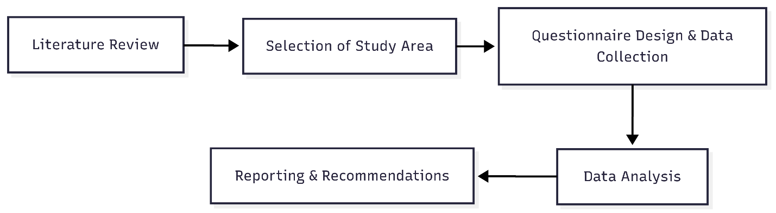

Figure 1: Research Process for Urban E-Waste Management Study

## Study Area: Rationale for Dhaka North & South

Dhaka, the capital and largest metropolitan area of Bangladesh, faces acute challenges regarding electronic waste (e-waste) management due to its rapid urbanization, high population density, and significant commercial activity. The city is administratively divided into Dhaka North City Corporation (DNCC) and Dhaka South City Corporation (DSCC), which reflect important differences in infrastructure, socioeconomic composition, and waste management practices. DNCC is characterized by newer residential developments and emerging commercial hubs, while DSCC includes older, denser neighborhoods and traditional markets. Both areas are known hotspots for electronic usage and informal e-waste processing (Islam et al., 2021; Rahman & Kim, 2021).

The decision to include both DNCC and DSCC in this study was made to capture a comprehensive and comparative perspective on e-waste generation, handling, and disposal. DNCC and DSCC exhibit contrasting patterns in terms of resource availability, public awareness, regulatory enforcement, and the prevalence of informal sector activity. By sampling both, the research allows for a nuanced understanding of how urban diversity shapes e-waste challenges and opportunities across different neighborhoods and commercial zones of Dhaka (Awasthi et al., 2016).

## Questionnaire Development: Section-Based Instrument Design

The survey instruments were meticulously designed after reviewing existing literature, local policy documents, and relevant international guidelines. The questionnaires are divided into logical sections to facilitate comprehensive data collection, clarity for respondents, and ease of analysis.

### Household E-Waste Survey Questionnaire

**Section 1: General Information**

* Collects city corporation (DNCC/DSCC) and household size.
* Enables demographic profiling and spatial mapping.

**Section 2: E-Waste Ownership, Generation & Disposal**

* Identifies types and quantities of electronic devices owned/used.
* Captures recent disposal activity, reasons for discarding (e.g., broken, obsolete), and estimated value of discarded e-waste.
* Asks about methods used to manage non-functional or obsolete electronics (storage, sale, donation, dumping, etc.).
* Reveals informal and formal pathways for e-waste.

**Section 3: Awareness and Attitudes**

* Measures knowledge of environmental/health risks, awareness of laws/guidelines, and sources of information (media, NGOs, etc.).

**Section 4: Barriers**

* Explores perceived obstacles to proper e-waste handling (lack of collection points, incentives, trust, etc.).
* Includes willingness to participate in incentive or collection programs.

**Section 5: Health and Environment**

* Asks about any e-waste-related health concerns in the household.

**Section 6: Suggestions**

* Provides open-ended space for recommendations and comments.

### Scrap Dealers E-Waste Survey Questionnaire

**Section 1: Basic Information**

* Collects business name (optional), location, respondent age, and nature of operation (individual/group).

**Section 2: E-Waste Work Practices**

* Captures duration of involvement in e-waste, types handled, sources of collection, and estimated monthly value.

**Section 3: Recycling & Dismantling**

* Asks about dismantling practices, end-destination of parts, safety equipment, and awareness of hazards.

**Section 4: Knowledge and Support**

* Probes awareness of regulations, willingness to receive training, management of hazardous materials, and desired support mechanisms.

**Section 5: Final Feedback**

* Collects final suggestions and comments from participants.

Sectional organization ensures that each key dimension—demographics, practices, awareness, barriers, and recommendations—is systematically covered for both households and scrap dealers.

## Sampling and Data Collection

This research employed a pragmatic and direct sampling approach, tailored to the realities of the two main study groups: households and informal scrap dealers in both DNCC and DSCC.

### Sampling Approach

**Households:**  
A snowball sampling method was used for the household survey. The Google Form containing the structured questionnaire was distributed initially among friends and family, who were then requested to share the survey link within their own networks. This approach enabled reach across various wards in both Dhaka North and South City Corporations and facilitated a diverse respondent pool in terms of socioeconomic and demographic background. While not strictly random, this method is practical for exploratory studies and for topics where formal lists of all households are unavailable

**Scrap Dealers:**

For the scrap dealer survey, a purposive and snowball sampling strategy was adopted. The research team first identified prominent e-waste hotspots, markets, and scrap trading locations in DNCC and DSCC through internet research and local inquiries. Team members then visited these locations in person and conducted face-to-face interviews with scrap dealers. After each interview, the dealer was asked to suggest other relevant contacts, which helped expand the sample network. Data was recorded using Google Forms on-site, ensuring immediate and accurate data capture.

**Sample Size:**

1. **Households:** 40
2. **Scrap Dealers:** 20 (10 from DNCC, 10 from DSCC)

These sample sizes were selected to balance the need for meaningful, comparative analysis with available resources and time

### Data Collection Process

For the household survey, the Google Form was shared digitally and completed online by respondents, many of whom were reached through personal and extended networks. The use of an online form increased accessibility and convenience, encouraging participation from a broader geographic and demographic spectrum within both city corporations.

For scrap dealers, data collection was conducted face-to-face. The research team visited targeted areas, conducted interviews in person, and entered responses directly into Google Forms during or immediately after each interaction. This approach allowed for real-time clarification of any ambiguities and built trust with participants, which is particularly important when working with informal sector actors.

### Data Management and Quality Control

All data collected via Google Forms (both from household and scrap dealer surveys) were automatically stored in a secure, centralized database. The research team regularly reviewed submissions to identify incomplete or inconsistent responses, which were flagged for follow-up where possible. Data was anonymized prior to analysis to protect respondent privacy. Only authorized team members had access to the raw data, and standard protocols were followed to ensure data integrity, in line with best practices for primary data collection in e-waste and urban studies

## Data Analysis Plan

The data analysis plan for this study is designed to systematically interpret and present the findings derived from both the quantitative and qualitative components of the research. The analysis is structured to address the research objectives and provide meaningful insights into urban e-waste management practices in Dhaka North and South City Corporations.

### Statistical Analysis

Quantitative data obtained from household and scrap dealer surveys will be analyzed using statistical techniques to identify trends, relationships, and central tendencies within the dataset. The following statistical methods will be employed:

* **Pearson Correlation Coefficient:** This will be used to assess the strength and direction of the linear relationship between key variables, such as awareness levels and e-waste disposal behavior.
* **Average/Mean:** The mean will be calculated for continuous variables (e.g., amount of e-waste generated per household, frequency of disposal) to provide a summary measure of central tendency.
* **Standard Deviation:** To measure the dispersion or variability around the mean, standard deviations will be computed for relevant variables, enabling the assessment of data spread and consistency.

Data will be processed and analyzed using statistical software such as SPSS or Microsoft Excel, ensuring accuracy and reliability in the results.

### Comparative analysis

A comparative analysis will be conducted to contextualize the findings of this study within the broader body of existing research on e-waste management. This will involve:

* Comparing the results obtained from Dhaka with findings of similar studies conducted in other developing countries or urban contexts, as reported in the literature (e.g., Awasthi et al., 2016; Islam et al., 2021).
* Identifying similarities and differences in e-waste generation rates, management practices, public awareness, and policy implementation.
* Discussing possible reasons for observed differences, such as socio-economic factors, regulatory environments, and levels of public engagement.

This approach will help to highlight the unique aspects of e-waste management in Dhaka, draw lessons from other contexts, and suggest practical recommendations for policy and practice.

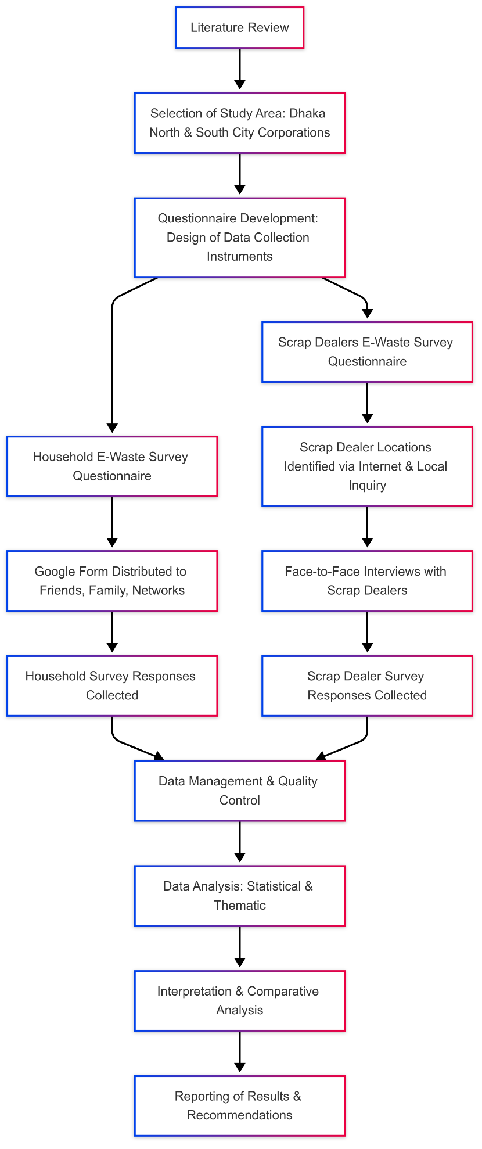

Figure 2: Operational Flow of Data Collection and Analysis for E-Waste Study

## Ethical Considerations

Informed consent was obtained from all participants prior to their involvement in the study. For the household survey, respondents were presented with a consent statement at the beginning of the Google Form, and only those who agreed proceeded with the questionnaire. For the scrap dealer survey, the research team sought verbal consent before conducting face-to-face interviews, explaining the purpose of the study and the voluntary nature of participation.

All data collected were anonymized to ensure participant confidentiality. Identifying information was neither requested nor stored, and responses were securely held in password-protected digital storage, accessible only to authorized research team members.

The study design, including questionnaire content and data collection protocols, was reviewed by all team members to ensure ethical soundness, respect for participant privacy, and cultural appropriateness within the local context.

## Limitations

This study focuses specifically on the perspectives and practices of households and informal scrap dealers in Dhaka North and South City Corporations. As such, it does not include insights from other important stakeholders such as NGOs, policymakers, or formal recycling companies, which may limit the comprehensiveness of the analysis.

Time and resource constraints influenced the sample sizes (40 households, 20 scrap dealers), which may affect the generalizability of the findings to the broader Dhaka population.

Furthermore, the inherently informal and sometimes sensitive nature of scrap dealing may have led to underreporting or reluctance in sharing certain information, despite efforts to build trust and ensure anonymity.

Despite these limitations, the structured, comparative, and context-specific design of the study provides meaningful and robust insights into the realities of urban e-waste generation and management in Dhaka.

# Result & Discussion

**Part 01: Household E-Waste Survey Analysis**

The Household survey has been structured into a data frame with 40 responses.

**Section 1: General Information**

1. City Corporation

Out of the 13 respondents, a mix of residents from Dhaka North and South participated. This distribution helps capture diverse urban e-waste habits, though a larger sample could improve representativeness.

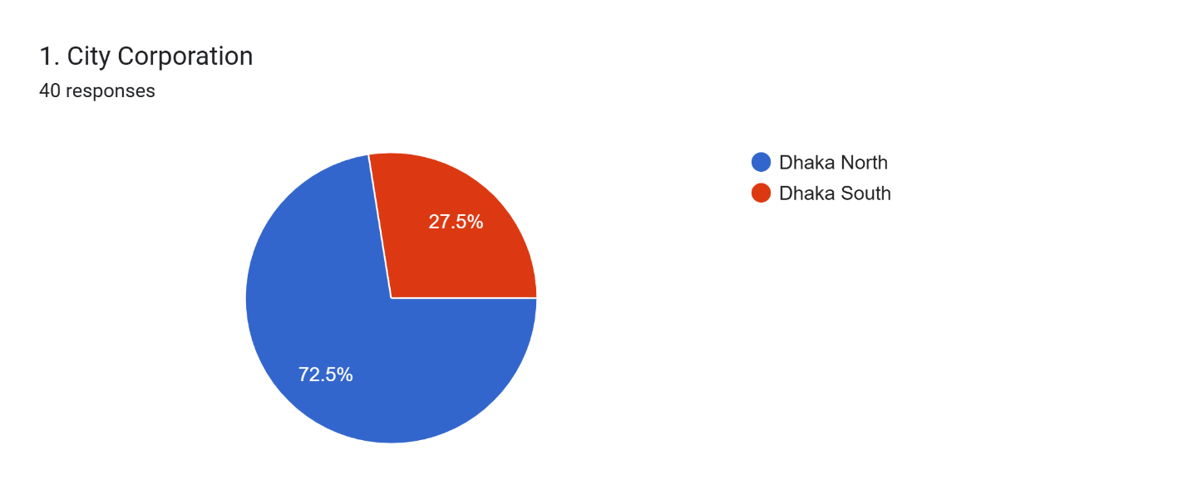

1. Household Size

Respondents reported varying household sizes, with most ranging between 4 to 6 members. This may influence the quantity of electronic products owned and discarded.

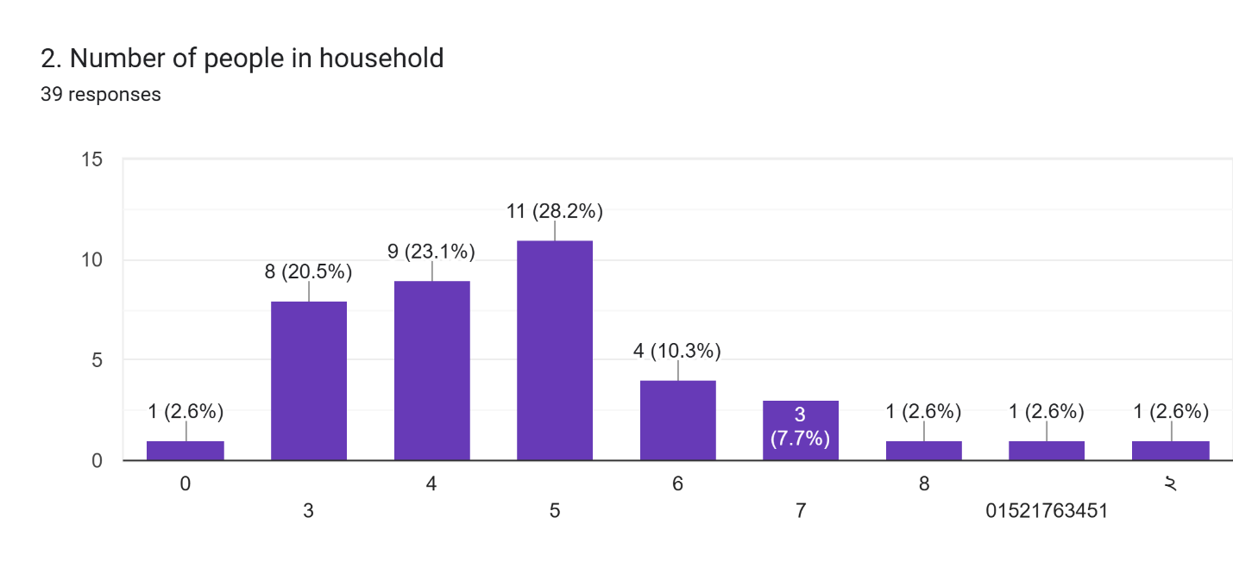

**Section 2: E-Waste Ownership, Generation & Disposal**

1. Ownership of Electronic Items

Most participants own common household electronics like mobile phones, laptops, and televisions. Refrigerators and washing machines were also widely owned, indicating a significant potential for domestic e-waste generation.

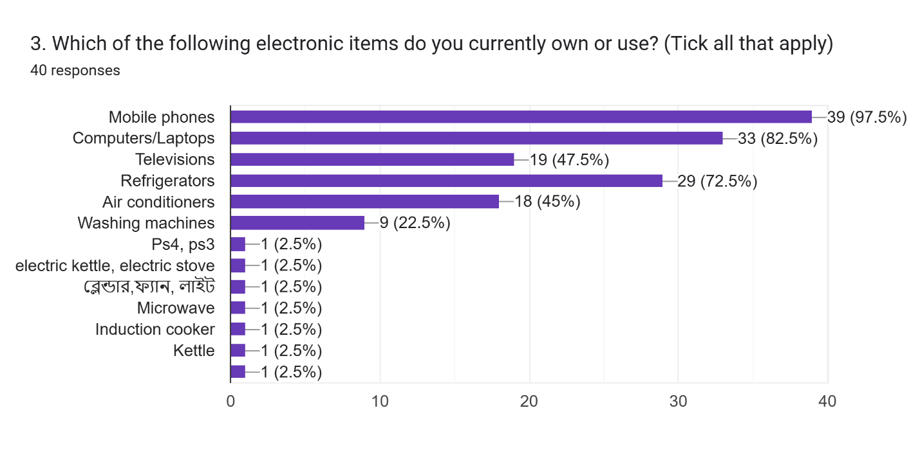

1. Discarded Items in the Past 12 Months

A noticeable portion of respondents have discarded at least one electronic item in the past year. This indicates an active generation of e-waste and potential opportunities for recycling or take-back programs.

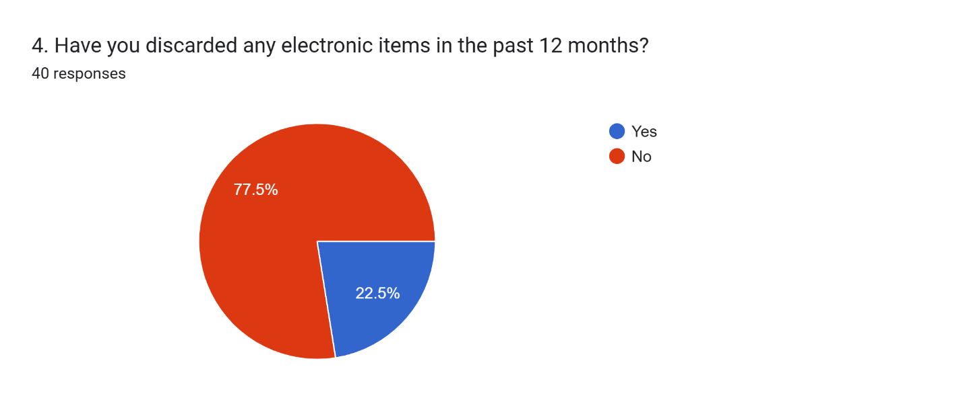

Reasons for Discarding Items

The most common reasons for discarding items were due to damage or obsolescence. This aligns with trends observed globally, where broken or outdated devices contribute heavily to e-waste volumes.

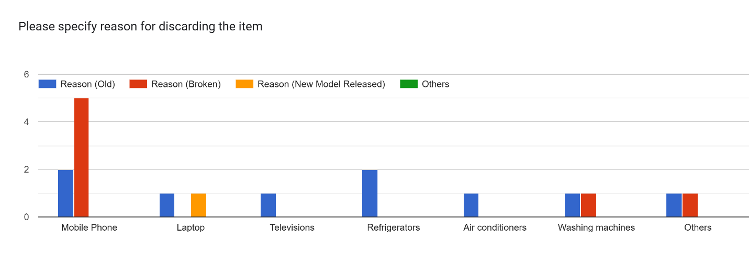

Estimated Value of Discarded Items

Although optional, a few respondents reported estimated values, highlighting the economic value lost when e-waste is improperly handled or discarded.

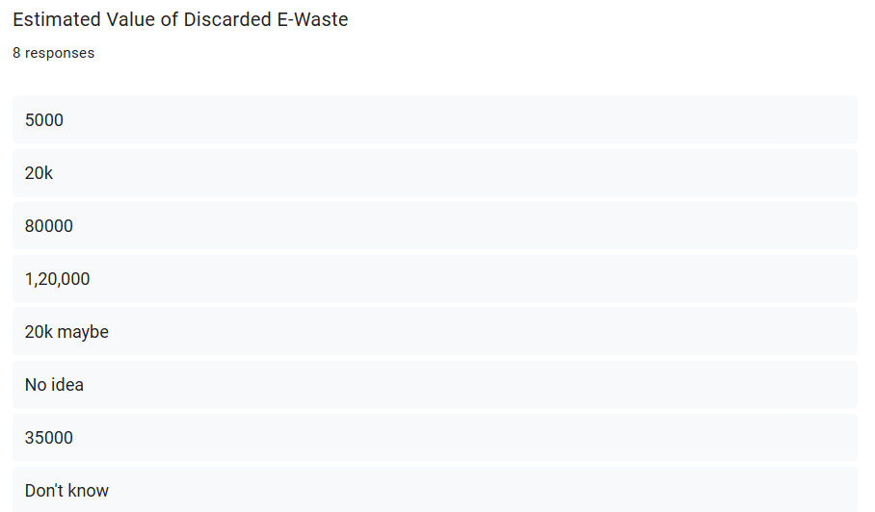

1. Common Disposal Practices

Most respondents reported either storing old electronics at home or selling them to informal collectors. Very few indicated using municipal collection points or returning to retailers, suggesting limited awareness or access to formal disposal systems.

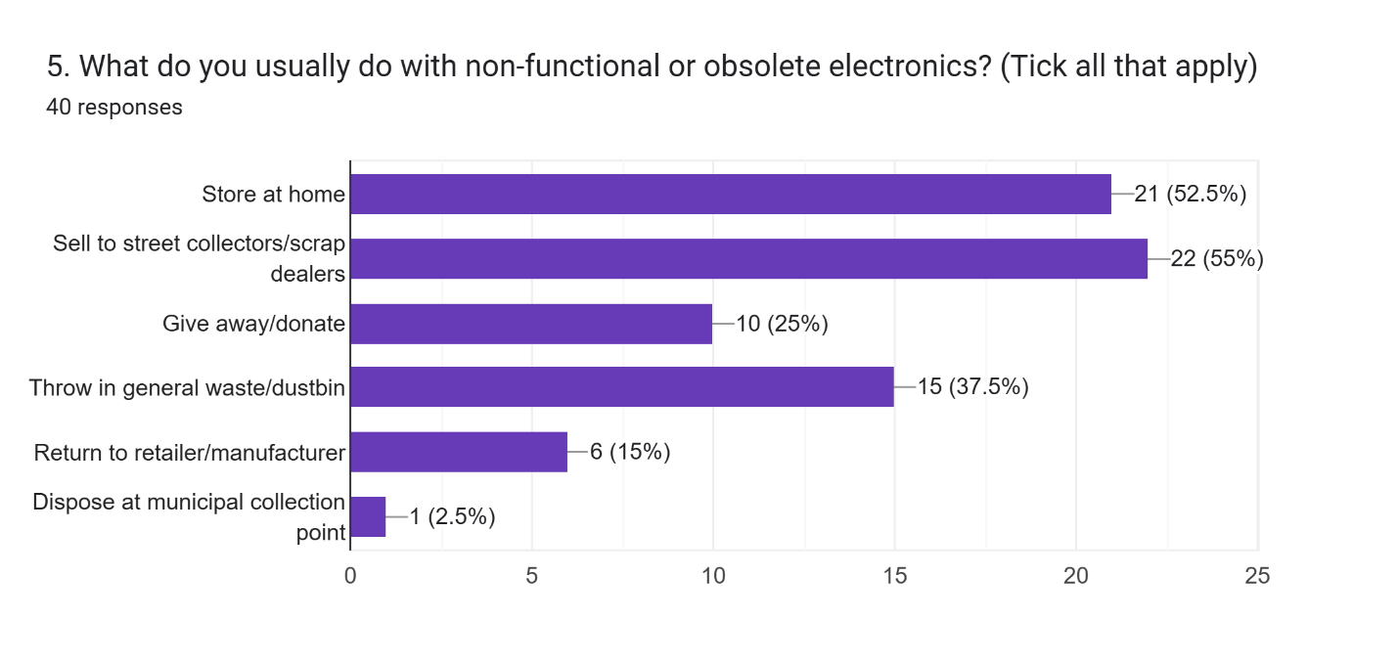

**Section 3: Awareness and Practices**

1. Awareness of Environmental/Health Risks

A majority of respondents are aware of the health and environmental risks associated with improper e-waste disposal. This awareness is encouraging but may not always translate into safe disposal behavior.

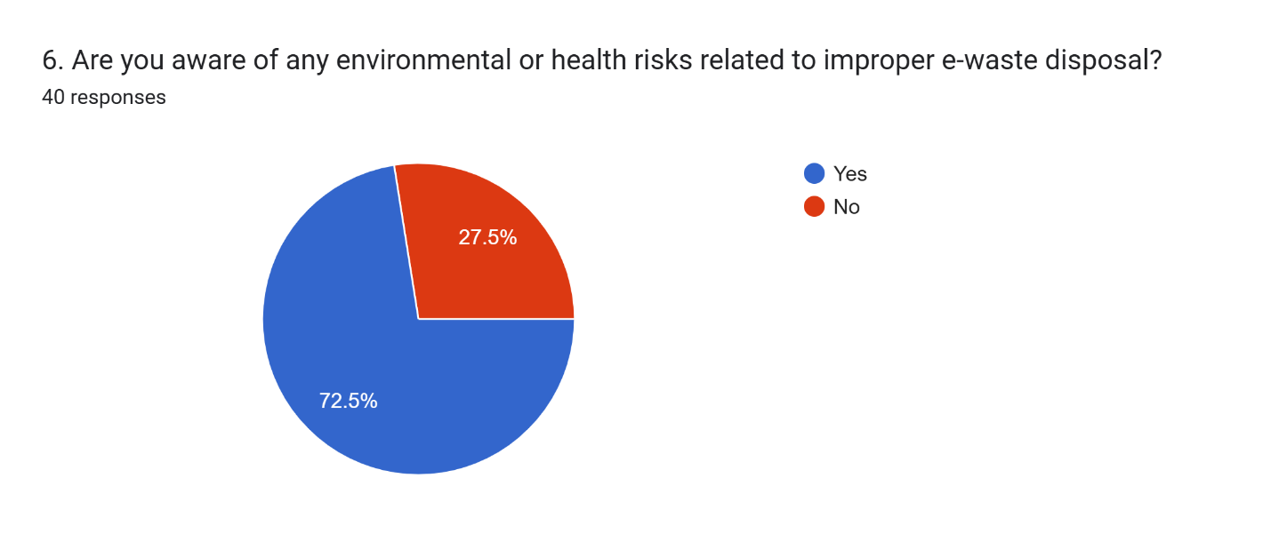

1. Familiarity with E-Waste Laws

Most respondents had not heard about existing laws on e-waste management in Bangladesh, underscoring a need for better communication and outreach from authorities.

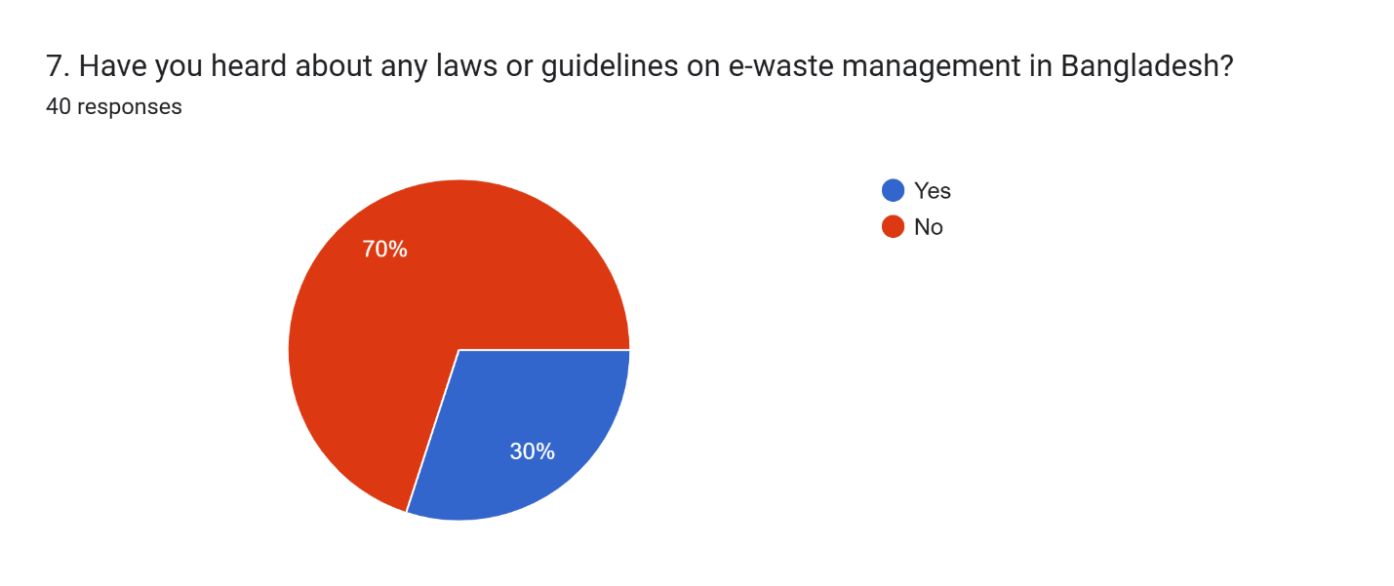

1. Sources of Information

Very few respondents reported receiving information from NGOs or media campaigns. This points to a gap in public education efforts on safe e-waste disposal practices.

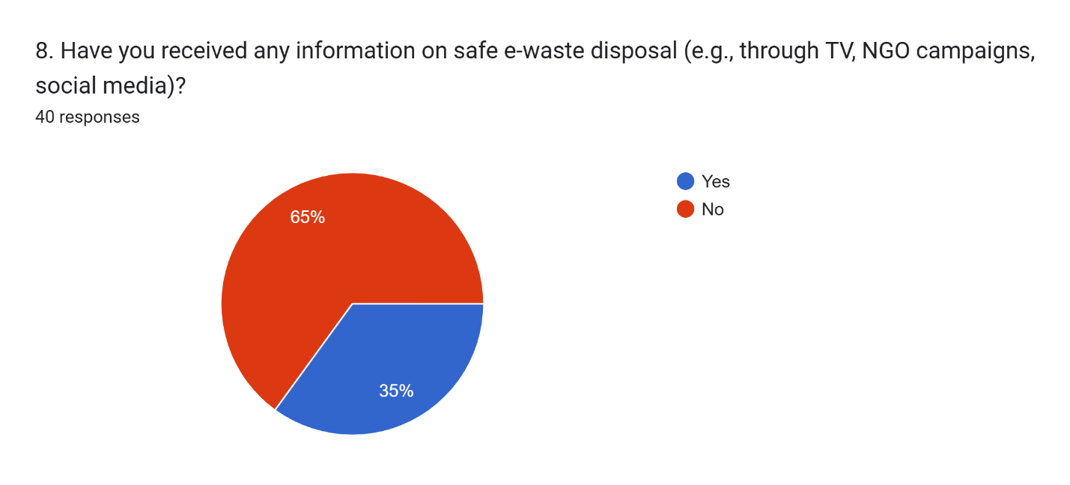

**Section 4: Barriers and Attitudes**

1. Reasons for Not Recycling or Properly Disposing

The top barriers included lack of awareness and absence of nearby collection points. These reflect systemic shortcomings that could be addressed through local infrastructure development and awareness campaigns.

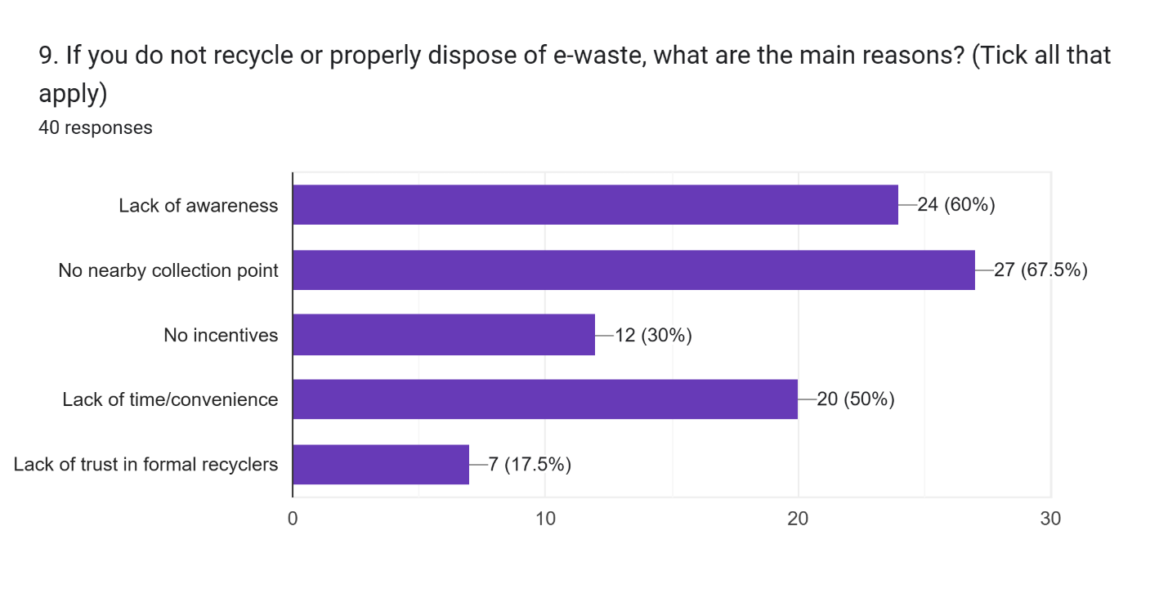

1. Willingness to Return E-Waste

Most respondents expressed willingness to return e-waste if provided with convenient services or incentives. This suggests that behavior change is possible with supportive policies and infrastructure.

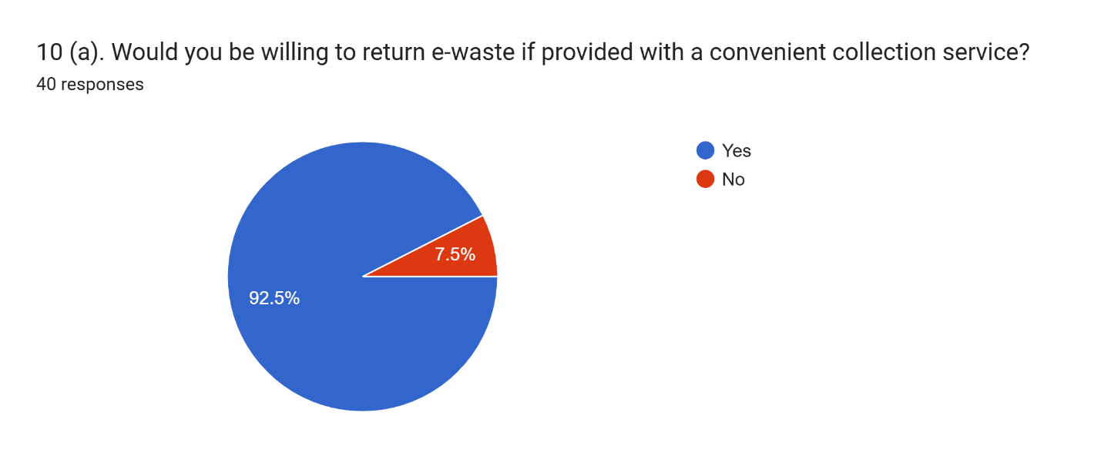

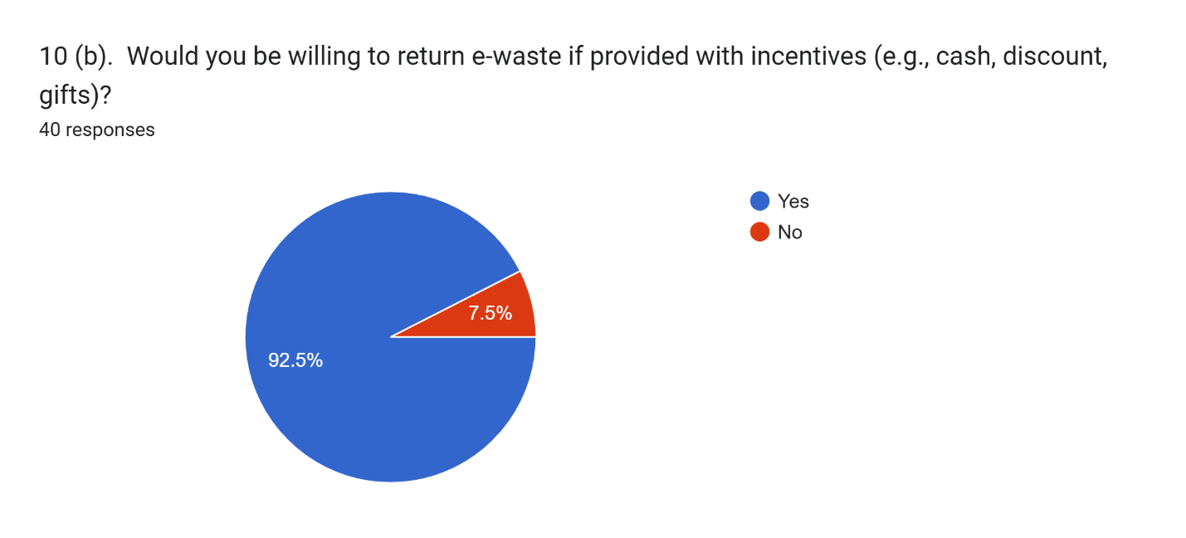

**Section 5: Health and the Environment**

1. Health Impacts

While a few participants reported health issues potentially linked to e-waste handling, most did not. However, given the small sample size and self-reporting limitations, this should be interpreted cautiously.

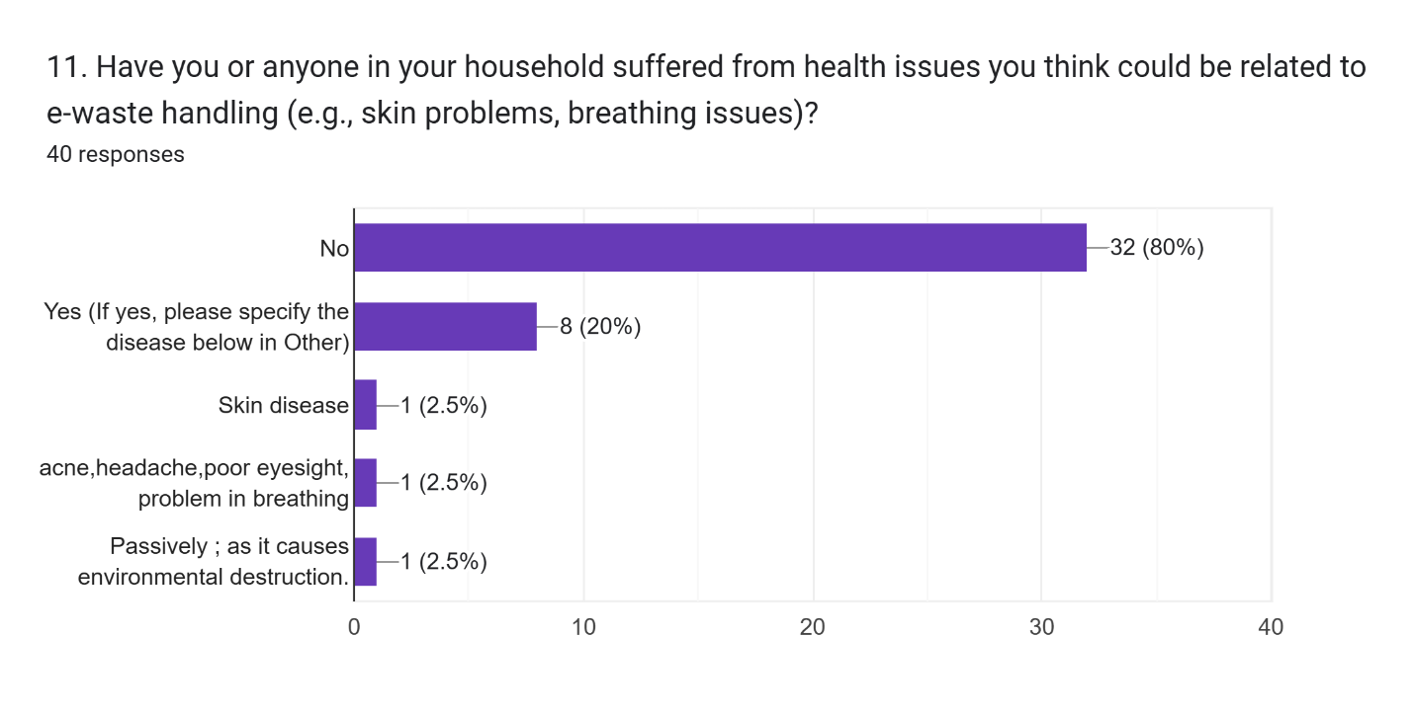

**Section 6: Suggestions**

1. Improving E-Waste Management

Respondents proposed solutions like increasing awareness, offering incentives, and establishing formal collection points. These ideas align with global best practices and could form the basis of community-focused interventions.

1. Additional Comments

Some participants emphasized the need for government action and stronger regulation. Others pointed to educational programs as a way to change disposal habits in the long term.

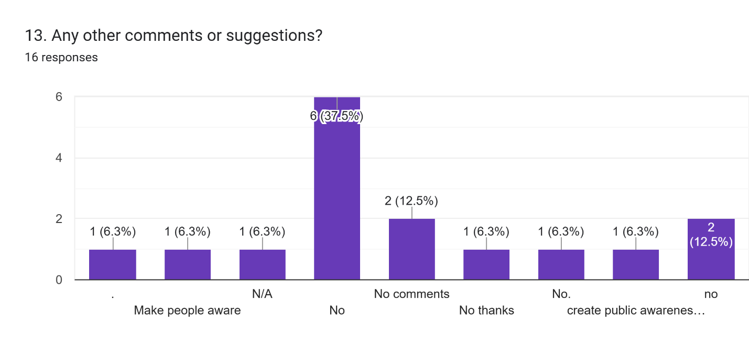

**Part 02: Scrap Dealers E-Waste Survey**

The Scrap Dealers E-Waste Survey has been structured into a data frame with 20 responses.

**Section 1: Basic Information**

1. **Business Name (Optional):**  
   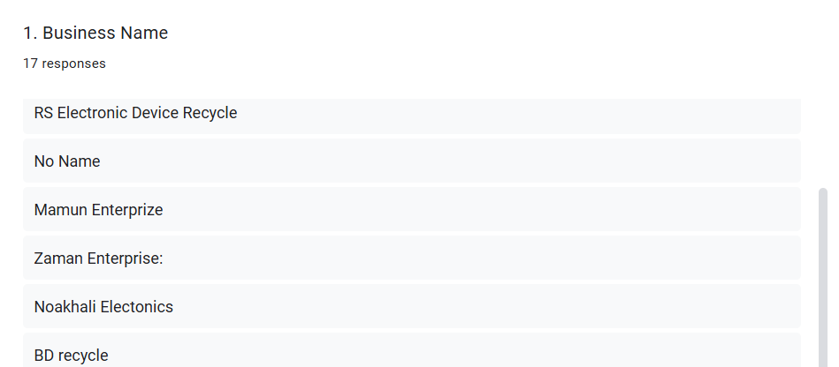
2. **City Corporation:**

The pie chart displays the distribution of respondents from different city corporations.

* **Dhaka North**: 50% of respondents
* **Dhaka South**: 50% of respondents

This equal distribution helps capture diverse urban e-waste habits, although a larger sample could improve representativeness.

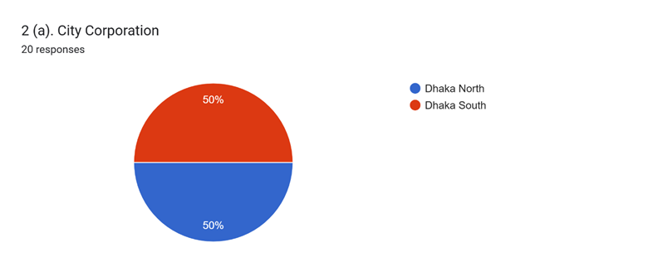

**Work Area / Locality (Thana / Ward / Road No.):**

Data was collected from respondents in specific areas, such as Kalshi and Nimtola.

1. **Age:**  
   Most respondents are between 26 and 35 years, reflecting an age group likely to own and dispose of electronics.

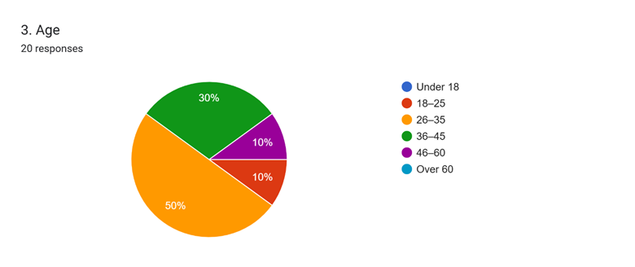

1. **Do you work individually or as part of a group/business?**  
   Majority of the people work as a part of a business.

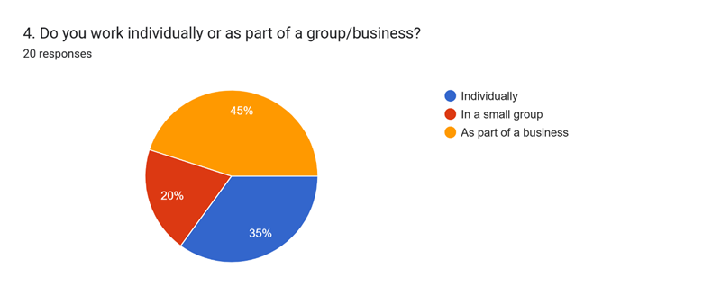

**Section 2: E-Waste Work Practices**

1. **How long have you been working with e-waste?**  
   The bar chart indicates the duration respondents have been working with e-waste.

**7 years**: 10%

**10 years**: 10%

**15 years**: 10%

**20 years**: 10%

**Other durations**: 5-10%

The data shows a range of experience, with most respondents working in the field for 7 to 20 years.

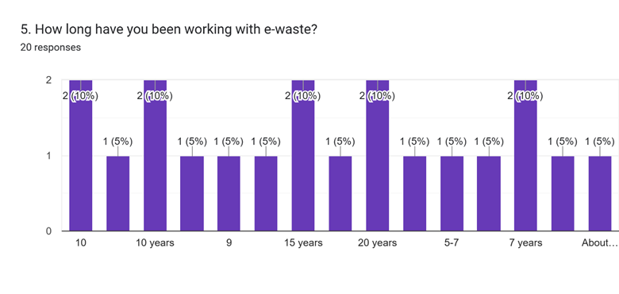

1. **Which types of e-waste do you handle most often?**   
   This bar chart lists the types of e-waste handled by respondents most frequently.

**Mobile Phones**: 55%

**Laptops/Computers**: 60%

**Televisions**: 50%

**Refrigerators**: 35%

Other items like air conditioners, batteries, and wires/cables were also mentioned, but less frequently.

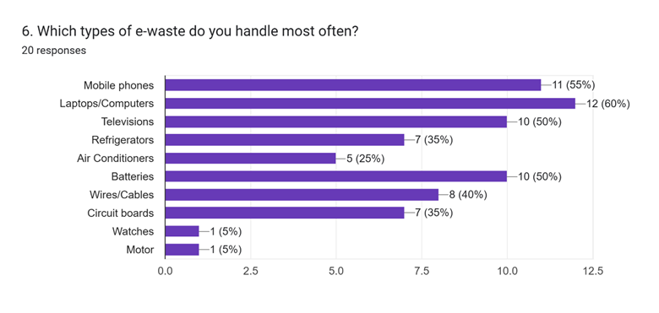

1. **Where do you collect e-waste from?**

This bar chart shows where respondents primarily collect e-waste from. E-waste collection is predominantly from households and offices, with electronic shops and scrap wholesalers also contributing.

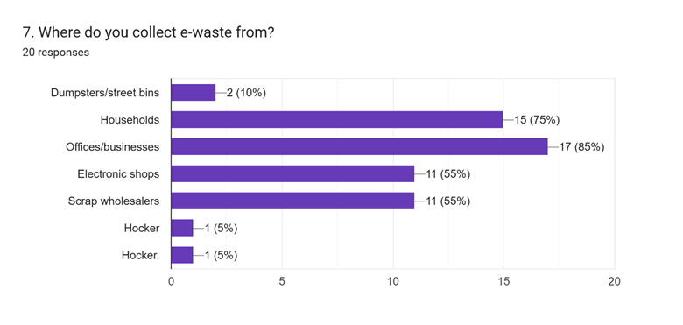

1. **How do you collect e-waste?**

Majority of e-waste is collected through buying the people.

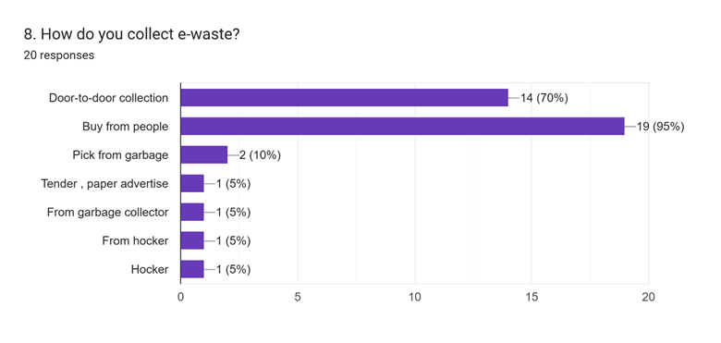

1. **Estimated Value of Discarded E-Waste (Per Month)**

The bar chart depicts the estimated value of discarded e-waste in Bangladeshi Taka (BDT) per month.The data shows a significant portion of respondents discarding e-waste valued between 30k and 50k BDT.

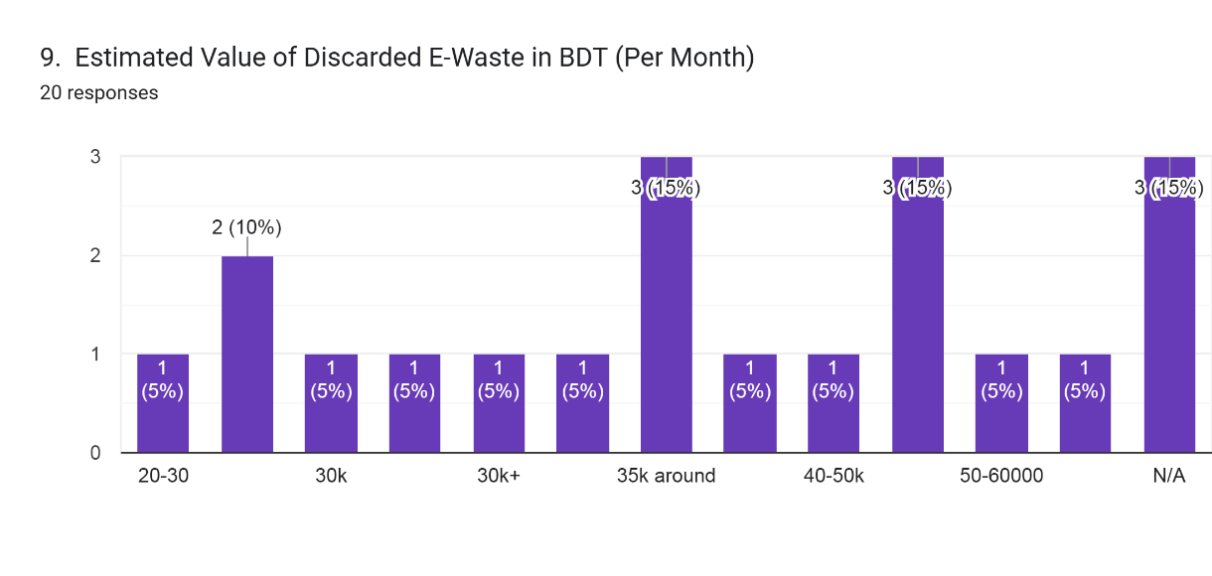

**Section 3: Recycling & Dismantling**

1. **Do you dismantle or process the e-waste yourself?**

The pie chart shows how respondents manage e-waste processing. Most respondents do not dismantle or process e-waste themselves, instead employing laborers for the task.

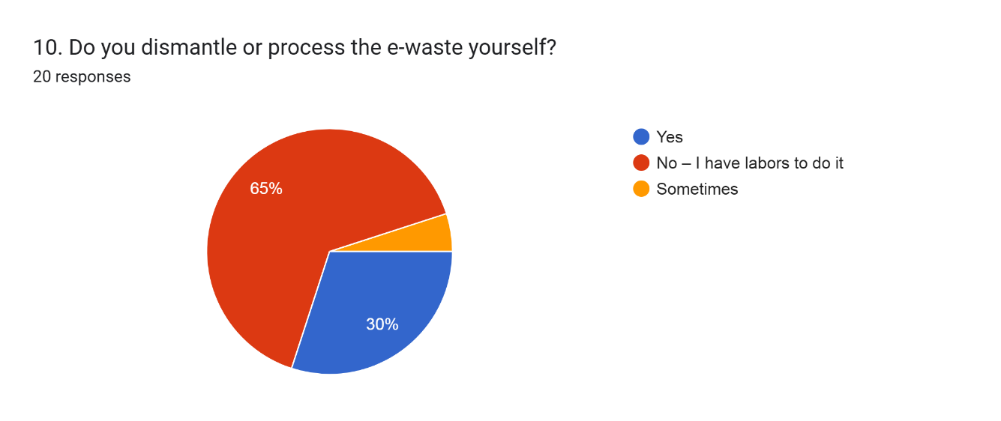

1. **What do you do with the parts after dismantling?**

Most respondents prefer selling usable parts and sending parts to larger recyclers, while a smaller number burn or discard unusable parts.

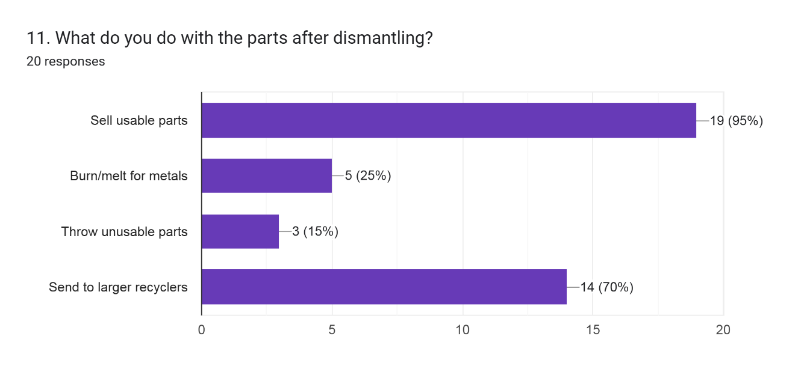

1. **Do you use any protective gear while working?**

Many respondents do not use protective gear, but a significant number wear masks or gloves while working with e-waste.

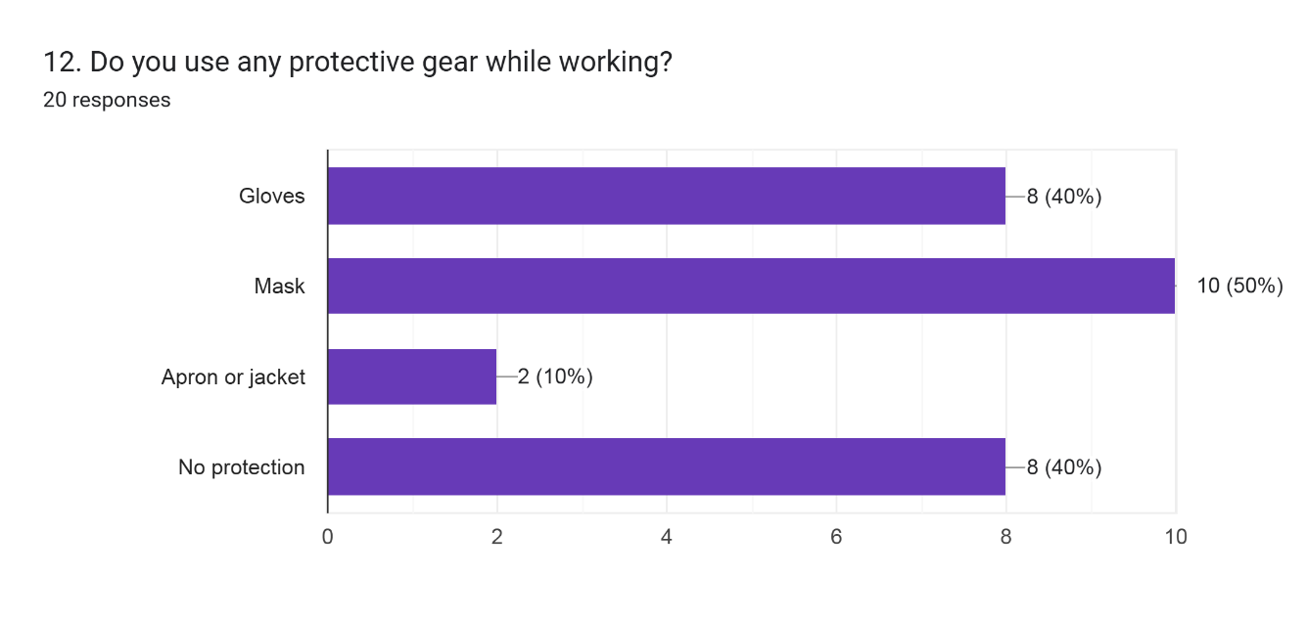

1. **Are you aware that some e-waste can harm your health or the environment?**

Most respondents are aware that e-waste can harm their health or the environment, but a portion of respondents are unaware of these risks.

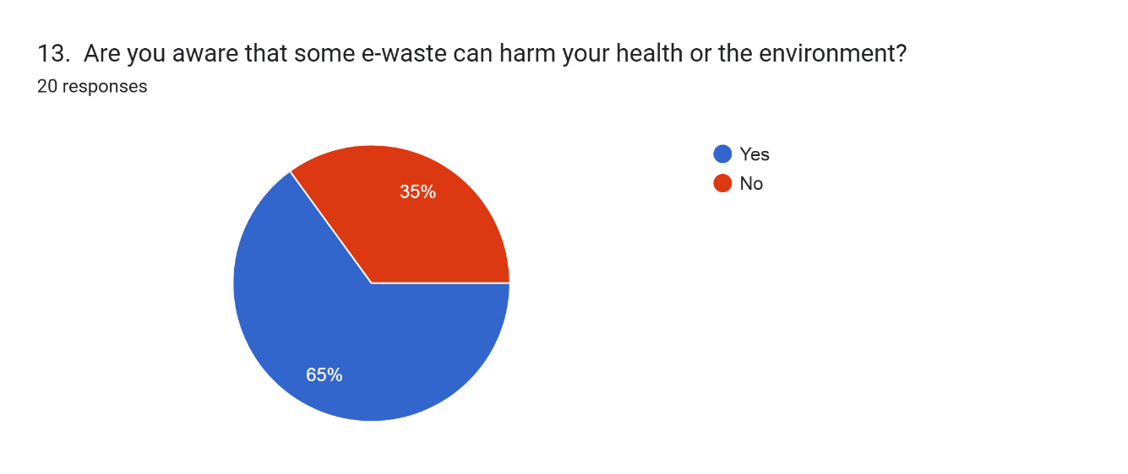

1. **Do you face any of the following problems in your work?**

Most respondents face issues related to a lack of proper tools, followed by concerns about health problems.

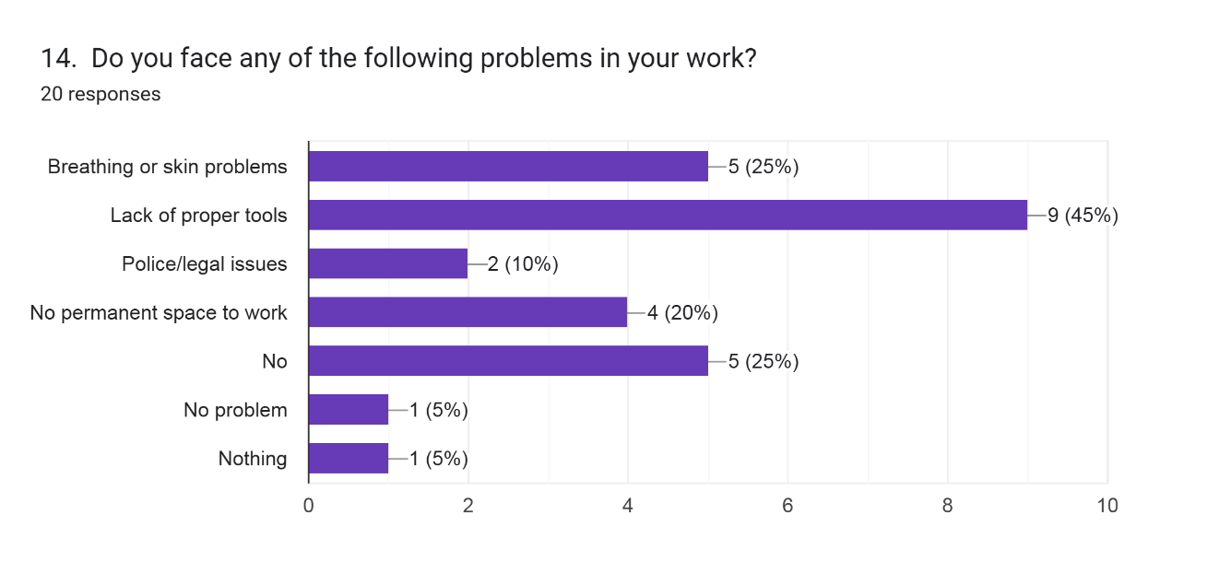

**Section 4: Knowledge and Support**

1. **Are you aware of any government rules or policies about e-waste?**

Most respondents are aware of government rules or policies related to e-waste, while a smaller portion is not familiar with them.

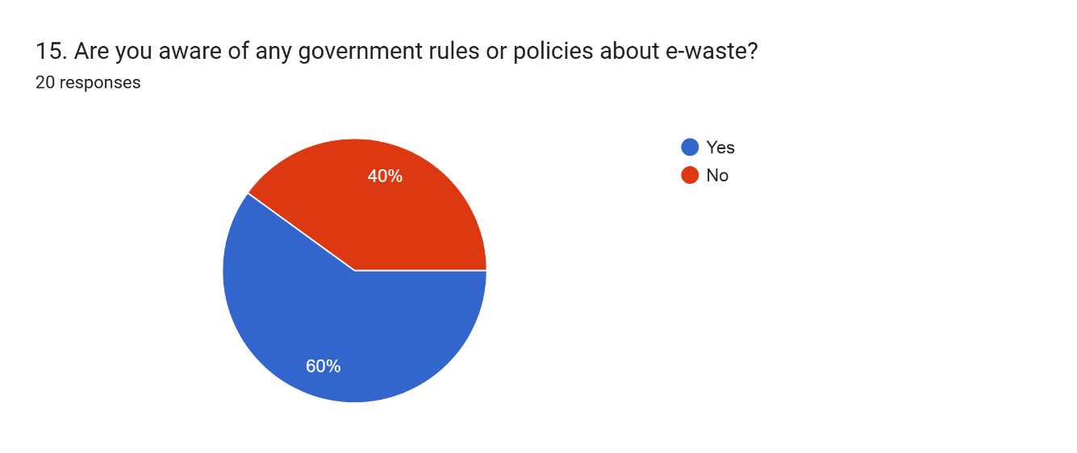

1. **Would you be interested in free training or a certificate on safe e-waste handling?**

Respondents are equally divided on their interest in training or certification, with a good portion unsure about it.

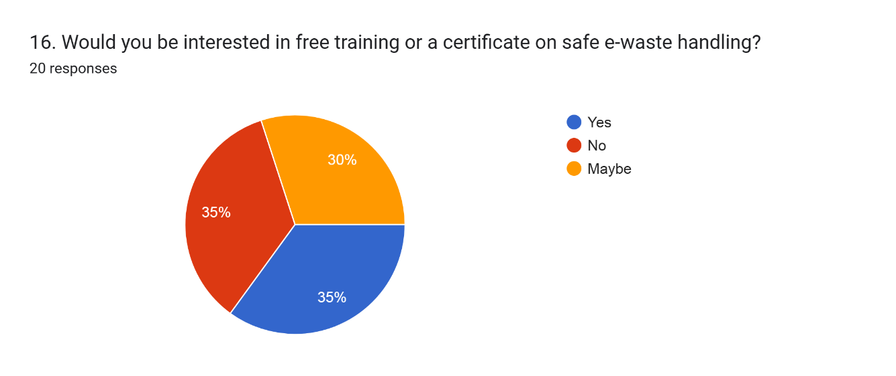

1. **How do you manage dangerous materials (like batteries, CRTs, or mercury parts)?**

A large percentage of respondents sell dangerous materials to specialized buyers, while others are less informed or improperly dispose of them.

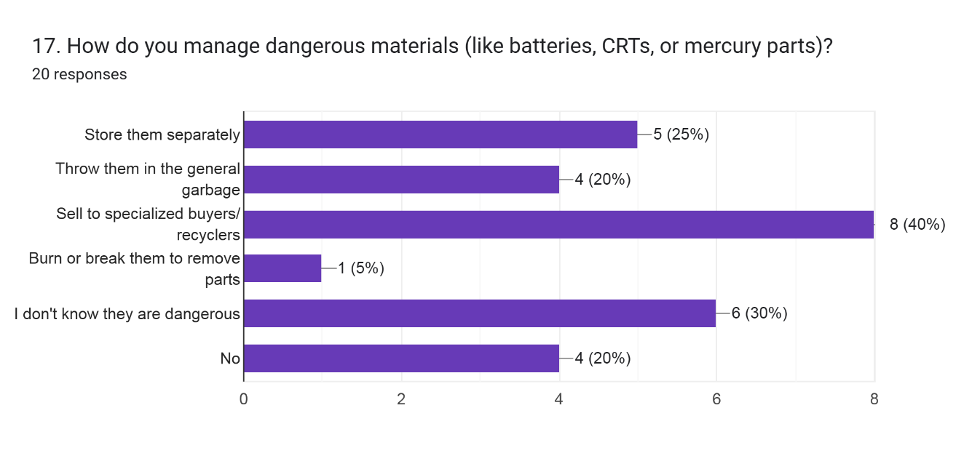

1. **What kind of support would help you do your work more safely and earn more?**

The majority of respondents (50%) would like help from the government to improve their work conditions and earnings.

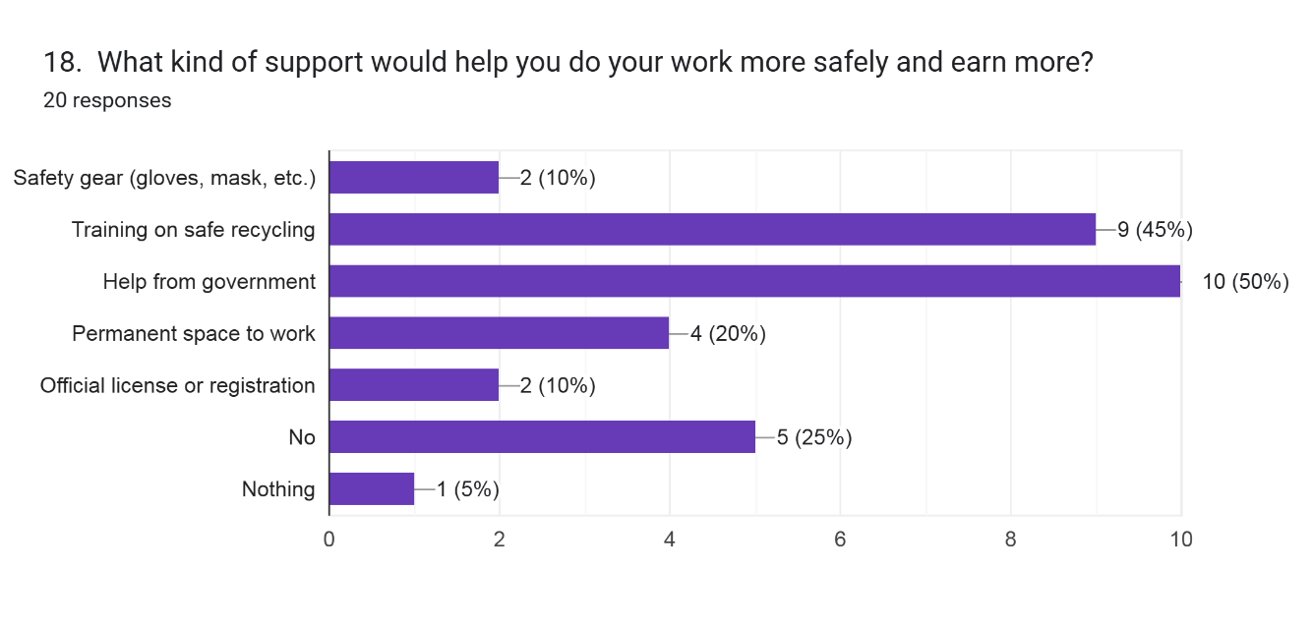

**Section 5: Final Feedback**

1. **Do you want to share anything else about your work or what you need?**

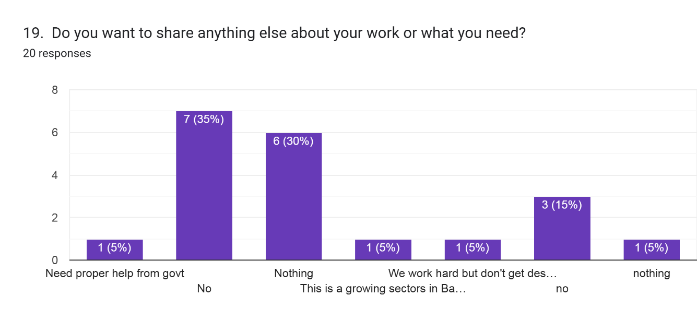

**Comparative Analysis**

**Statistical Analysis**

# Conclusion

Survey findings underscore Dhaka’s systemic weaknesses in e-waste management, rooted in high electronics usage, poor disposal practices, and limited public understanding of the consequences. Most households either store obsolete devices or pass them to unregulated informal collectors, with very few utilizing formal channels due to lack of infrastructure and awareness. Scrap dealers, who dominate the collection system, operate under unsafe, unhygienic, and environmentally damaging conditions, often dismantling electronics using crude methods. This not only endangers their health but also contributes to pollution and loss of recoverable materials. However, a clear opportunity exists to realign the system through circular economy principles—reducing waste, extending product life, and reintegrating materials into production cycles. Both residents and collectors show a willingness to participate in safer practices if given the means and support. Without immediate intervention, the environmental and public health toll will only worsen. Embracing a circular economy approach is essential for creating a more sustainable and resilient e-waste management system in Dhaka.

# Recommendations

E-waste in Dhaka needs an end-to-end, policy-based circular economy-led solution involving development of infrastructure, public engagement, policy reform, and regulation of informal economies. City-wide collection centers for e-waste, mobile collection drives, and manufacturer take-back programs need to be initiated to render disposal convenient and accessible. Educational and media campaigns must inform the public on safe disposal and risks associated with improper handling. Motivate families by offering discounts, buy-back, or rewards. The informal sector needs to be registered and offered training, protective gear, and facilities to make them drivers of the circular economy. Alliances with certified recycling facilities must be established to make material recovery green. Investment in organized recycling facilities, strict enforcement of EPR policy, and tax breaks for conforming producers must also be undertaken. Last but not least, reuse and refurbishment must be encouraged through standardized hubs and donation chains, extending the life of electronics and lowering waste—putting Dhaka on the path to a circular, resilient, and sustainable e-waste management system.

#### References

Ahmed, M. and Mahmud, K., 2019. *Urban e-waste management: Bangladesh perspective*. In: International Conference on Sustainable Infrastructure Development. pp.118–125.

Alam, M.J.B. and Haque, M.E., 2022. *Assessment of e-waste governance in Bangladesh*. Sustainable Environment Research, 32(1), pp.1–10. Available at: <https://doi.org/10.1186/s42834-021-00107-7>.

Awasthi, A. K., Zeng, X., & Li, J. (2016)  
'Environmental pollution of electronic waste recycling in developing countries: A review', *Environmental Pollution*, 211, pp. 259–270.

Balde, C.P., Forti, V., Gray, V., Kuehr, R. and Stegmann, P., 2017. *The Global E-waste Monitor 2017: Quantities, Flows and Resources*. Bonn: United Nations University.

Borthakur, A. and Govind, M., 2017. *Emerging trends in consumers’ E-waste disposal behaviour and awareness: A worldwide overview with special focus on India*. Resources, Conservation and Recycling, 117, pp.102–113. Available at: <https://doi.org/10.1016/j.resconrec.2016.10.005>.

Dasgupta, S., Roy, M., Sarker, S. and Farzana, M.T., 2021. *Exposure of e-waste workers to health hazards: A neglected issue in urban Bangladesh*. Environmental Research, 194, p.110642. Available at: <https://doi.org/10.1016/j.envres.2020.110642>.

ESDO, 2020. *Situation Analysis of E-waste Management in Bangladesh*. Dhaka: Environment and Social Development Organization.

European Commission, 2020. *Directive 2012/19/EU on Waste Electrical and Electronic Equipment (WEEE)*. Brussels: European Commission. Available at: <https://eur-lex.europa.eu/legal-content/EN/TXT/?uri=CELEX:32012L0019> [Accessed 23 June 2025].

Hossain, M., Meem, R., Khan, R. & Ahmed, A., 2021. A Review on the environmental and health impacts due to electronic waste disposal in Bangladesh. GSC Advanced Research and Reviews. Available at: <https://doi.org/10.30574/gscarr.2021.8.2.0174>.

Hsu, J., Stern, M. & Wang, J., 2024. E-Waste: A Global Problem, Its Impacts, and Solutions. Journal of Global Information Management, 32, pp.1–28. Available at: <https://doi.org/10.4018/jgim.337134>.

Iqbal, M., Nilsson, D. and Halder, P., 2022. *Understanding public engagement in e-waste management in Sweden: Policy and practice insights*. Journal of Cleaner Production, 337, p.130432. Available at: <https://doi.org/10.1016/j.jclepro.2022.130432>.

Islam, M. T., Abdullah, A. B., Shahir, S. A., Kalam, A., & Idris, A. (2021)  
'A Systematic Review of E-Waste Generation and Environmental Management Practices in Developing Countries', *International Journal of Environmental Research and Public Health*, 18(17), 9051. <https://doi.org/10.3390/ijerph18179051>

Islam, M.T. and Huda, N., 2018. *E-waste in Bangladesh: Challenges and policy implications*. Waste Management, 76, pp.708–716. Available at: <https://doi.org/10.1016/j.wasman.2018.03.046>.

Islam, N., Rahman, E., Aich, N. & Mowla, M., 2021. Assessment of Heavy Metal Contamination and Health Risk from Indoor Dust and Air of Informal E-waste Recycling Shops in Dhaka, Bangladesh. Journal of Hazardous Materials Advances. Available at: <https://doi.org/10.1016/j.hazadv.2021.100025>.

Park, J., Kim, J., Lee, S. and Seo, Y., 2022. *Formalization of the informal e-waste sector in South Korea: Challenges and integration strategies*. Journal of Environmental Management, 308, p.114603. Available at: <https://doi.org/10.1016/j.jenvman.2022.114603>.

Patwa, N., Sivarajah, U., Seetharaman, A., Sarkis, J., Mathiyazhagan, K. and Khor, K.S., 2021. *The transition towards a circular economy: A strategic perspective for the electronics sector in developing countries*. Resources, Conservation and Recycling, 164, p.105170. Available at: <https://doi.org/10.1016/j.resconrec.2020.105170>.

Rahman, M. R. & Kim, J. R. (2021)  
'Sustainable electronic waste management among households: a circular economy perspective', *Management of Environmental Quality: An International Journal*, 32(5), pp. 910-925. <https://doi.org/10.1108/MEQ-06-2020-0128>

Rahman, M.M. and Islam, M.T., 2019. *E-waste management in Bangladesh: Current practices, problems and prospects*. Journal of Environmental Management, 231, pp.786–797. Available at: <https://doi.org/10.1016/j.jenvman.2018.10.037>.

Taipei Times, 2015. [online] Available at: <https://www.taipeitimes.com/News/front/archives/2015/12/18/2003635061> [Accessed 23 June 2025].

Widmer, R., Oswald-Krapf, H., Sinha-Khetriwal, D., Schnellmann, M. and Böni, H., 2005. *Global perspectives on e-waste*. Environmental Impact Assessment Review, 25(5), pp.436–458. Available at: <https://doi.org/10.1016/j.eiar.2005.04.001>.

Yoshida, A., Terazono, A. and Kojima, M., 2016. *Current status and future perspective of e-waste recycling in Japan*. Journal of Material Cycles and Waste Management, 18(1), pp.1–10. Available at: <https://doi.org/10.1007/s10163-015-0370-6>.

#### Appendices

##### Survey Questionnaire Tools

1. **Household E-Waste Survey Questionnaire**

**Section 1: General Information**

1. City Corporation: ☐ Dhaka North ☐ Dhaka South
2. Number of people in household: ________

**Section 2: E-Waste Ownership and Generation**

1. Which of the following electronic items do you currently own or use? (Tick all that apply)

☐ Mobile phones

☐ Computers/Laptops

☐ Televisions

☐ Refrigerators

☐ Air conditioners

☐ Washing machines

☐ Other (specify): ____________________

1. Have you discarded any electronic items in the past 12 months? ☐ Yes ☐ No

If yes, why?

|  |  |
| --- | --- |
| Type of item | Reason (Broken/Old/etc) |
| Mobile Phone |  |
| Laptop |  |
| TV |  |

1. **Estimated Value of Discarded E-Waste**  
   *(Optional)*
2. Approximate value in BDT: _____________
3. What do you usually do with non-functional or obsolete electronics? (Tick all that apply)

☐ Store at home

☐ Sell to street collectors/scrap dealers

☐ Give away/donate

☐ Throw in general waste/dustbin

☐ Return to retailer/manufacturer

☐ Dispose at municipal collection point

☐ Other (specify): ____________________

**Section 3: Awareness and Practices**

1. Are you aware of any environmental or health risks related to improper e-waste disposal?
   * 1. ☐ Yes
     2. ☐ No
2. Have you heard about any laws or guidelines on e-waste management in Bangladesh?
   * 1. ☐ Yes
     2. ☐ No
3. Have you received any information on safe e-waste disposal (e.g., through TV, NGO campaigns, social media)?
   * 1. ☐ Yes
     2. ☐ No

**Section 4: Barriers and Attitudes**

1. If you do not recycle or properly dispose of e-waste, what are the main reasons? (Tick all that apply)
   * 1. ☐ Lack of awareness
     2. ☐ No nearby collection point
     3. ☐ No incentives
     4. ☐ Lack of time/convenience
     5. ☐ Lack of trust in formal recyclers
     6. ☐ Other (specify): ______________
2. Would you be willing to return e-waste if provided with:
   * Convenient collection service? ☐ Yes ☐ No
   * Incentives (e.g., cash, discount, gifts)? ☐ Yes ☐ No

**Section 5: Health and the Environment**

1. Have you or anyone in your household suffered from health issues you think could be related to e-waste handling (e.g., skin problems, breathing issues)?

☐ Yes (specify): ________________

☐ No

**Section 6: Suggestions**

1. What do you think would improve e-waste management in your area?
2. Any other comments or suggestions?
3. **Scrap Dealers E-Waste Survey Questionnaire**

**Section 1: Basic Information**

1. **Business Name (Optional):**  
   [Short answer]
2. **City Corporation:**  
   ☐ Dhaka North  
   ☐ Dhaka South

**Work Area / Locality (Thana / Ward / Road No.):**  
[Short answer]

1. **Age:**  
   ☐ Under 18  
   ☐ 18–25  
   ☐ 26–35  
   ☐ 36–45  
   ☐ 46–60  
   ☐ Over 60
2. **Do you work individually or as part of a group/business?**  
   ☐ Individually  
   ☐ In a small group  
   ☐ As part of a business  
   ☐ Other (specify): ___________

**Section 2: E-Waste Work Practices**

1. **How long have you been working with e-waste?**  
   [Short answer – e.g., “2 years”]
2. **Which types of e-waste do you handle most often?** *(Select all that apply)*  
   ☐ Mobile phones  
   ☐ Laptops/Computers  
   ☐ Televisions  
   ☐ Refrigerators  
   ☐ Air Conditioners  
   ☐ Batteries  
   ☐ Wires/Cables  
   ☐ Circuit boards  
   ☐ Other (specify): ___________
3. **Where do you collect e-waste from?** *(Select all that apply)*  
   ☐ Dumpsters/street bins  
   ☐ Households  
   ☐ Offices/businesses  
   ☐ Electronic shops  
   ☐ Scrap wholesalers  
   ☐ Other (specify): ___________
4. **How do you collect e-waste?**  
   ☐ Door-to-door collection  
   ☐ Buy from people  
   ☐ Pick from garbage  
   ☐ Other (specify): ___________
5. **Estimated Value of Discarded E-Waste (Per Month)**  
   *(Optional)*
6. Approximate value in BDT: _____________

**Section 3: Recycling & Dismantling**

1. **Do you dismantle or process the e-waste yourself?**  
   ☐ Yes  
   ☐ No – I have labors to do it  
   ☐ Sometimes
2. **What do you do with the parts after dismantling?** *(Select all that apply)*  
   ☐ Sell usable parts  
   ☐ Burn/melt for metals  
   ☐ Throw unusable parts  
   ☐ Send to larger recyclers  
   ☐ Other: ___________
3. **Do you use any protective gear while working?** *(Select all that apply)*  
   ☐ Gloves  
   ☐ Mask  
   ☐ Apron or jacket  
   ☐ No protection  
   ☐ Other: ___________
4. **Are you aware that some e-waste can harm your health or the environment?**  
   ☐ Yes  
   ☐ No
5. **Do you face any of the following problems in your work?** *(Select all that apply)*  
   ☐ Breathing or skin problems  
   ☐ Lack of proper tools  
   ☐ Police/legal issues  
   ☐ No permanent space to work  
   ☐ Other: ___________

**Section 4: Knowledge and Support**

1. **Are you aware of any government rules or policies about e-waste?**  
   ☐ Yes  
   ☐ No
2. **Would you be interested in free training or a certificate on safe e-waste handling?**  
   ☐ Yes  
   ☐ No  
   ☐ Maybe
3. **How do you manage dangerous materials (like batteries, CRTs, or mercury parts)?**  
   *(Select all that apply)*  
   ☐ Store them separately  
   ☐ Throw them in the general garbage  
   ☐ Sell to specialized buyers/recyclers  
   ☐ Burn or break them to remove parts  
   ☐ I don't know they are dangerous  
   ☐ Other (specify): ___________
4. **What kind of support would help you do your work more safely and earn more?** *(Select all that apply)*  
   ☐ Safety gear (gloves, mask, etc.)  
   ☐ Training on safe recycling  
   ☐ Help from government  
   ☐ Permanent space to work  
   ☐ Official license or registration  
   ☐ Other: ___________

**Section 5: Final Feedback**

1. **Do you want to share anything else about your work or what you need?**  
   [Paragraph]

##### Studay Area Location

Nobab Katara Nimtoli Dhaka 1000 (Dhaka South City Corporation)

Location: [Goggle Map](https://goo.gl/maps/H8FHMp3rYGDBR8py7)

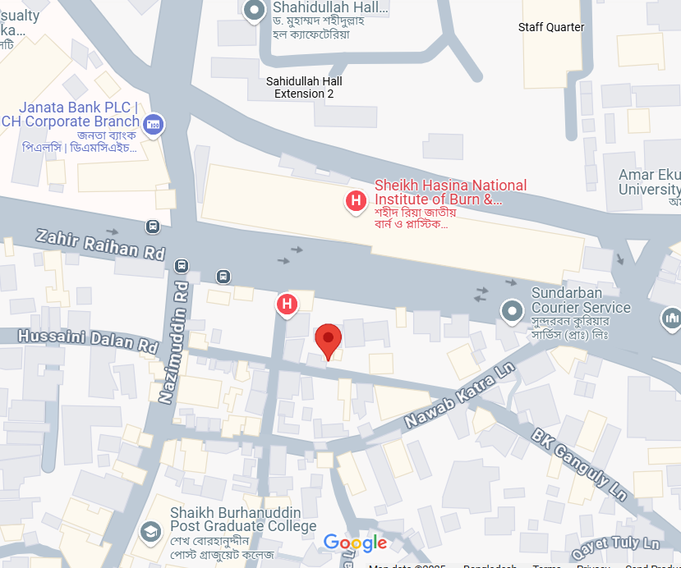

Figure : Location of Scrap Dealers E-Waste Survey

Adorsho Nogor, Block-E, Section-11, Mirpur (Dhaka North City Corporation)

Location: [Google Map](https://maps.app.goo.gl/QHqHjbMbhFLYjaCT8)

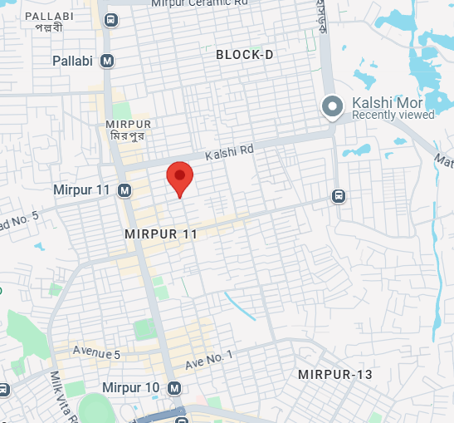

Figure : Location of Scrap Dealers E-Waste Survey

##### Study Area Details

